Practice Question 1:

<!DOCTYPE html>

<html lang="en">

<head>

    <meta charset="UTF-8">

    <meta name="viewport" content="width=device-width, initial-scale=1.0">

    <title></title>

    <style>

        .square {

          height: 50px;

          width: 50px;

          background-color:red;

          font-size: 12px;

          text-align: center;

          color: white;

        }

        #square {

            height: 50px;

          width: 50px;

          background-color:blue;

          font-size: 12px;

          text-align: center;

          color: white;

        }

        #square1 {

            height: 50px;

          width: 50px;

          background-color:black;

          font-size: 12px;

          text-align: center;

          color: white;

        }

        </style>

</head>

<body>

    <table border="2">

        <caption>Members Data</caption>

        <tr>

            <th>Group</th>

            <th>Avatar</th>

            <th>Name</th>

            <th> E-mail</th>

            <th> Character</th>

            <th> Profile</th>

        </tr>

        <tr>

            <td rowspan="2">Ninja</td>

            <td class="square">50X50</td>

            <td>Osama Mohamed</td>

            <td>o1@nn.sa<hr>o2.nn.sa</td>

            <td>&copy;</td>

            <td><a href=" ">Profile</a></td>

        </tr>

        <tr>

            <td id="square">50X50</td>

            <td>Shady Nabil</td>

            <td>s@nn.sa</td>

            <td>&#153</td>

            <td><a href=" ">Profile</a></td>

        </tr>

        <tr>

            <td>Monsters</td>

            <td id="square1">50X50</td>

            <td>Mohamed Ibrahim</td>

            <td>m@nn.sa</td>

            <td>&reg;</td>

            <td><a href=" ">Profile</a></td>

        </tr>

        <tr>

            <td colspan="5"> Total Members</td>

            <td>3</td>

        </tr>

    </table>

</body>

</html>

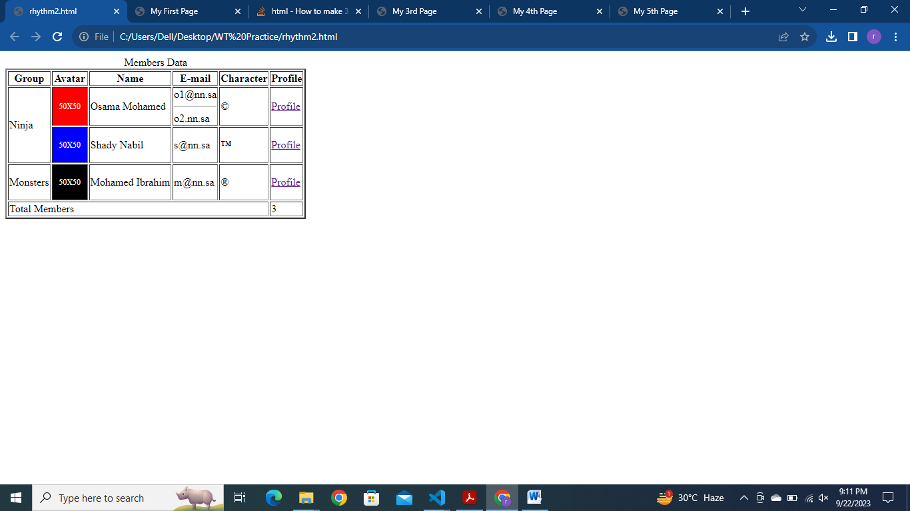

Practice Question 2:

<!DOCTYPE html>

<html lang="en">

<head>

    <meta charset="UTF-8">

    <meta name="viewport" content="width=device-width, initial-scale=1.0">

    <title>My First Page</title>

    <style>

        .square {

          height: 80px;

          width: 120px;

          background-color:red;

         font-size: 12px;

          text-align: center;

          margin: 10px;

          color: white;

         float: left;

         padding-top: 50px;

        }

        #square {

            height: 80px;

          width: 120px;

          background-color:blue;

           font-size: 12px;

          text-align: center;

          margin: 10px;

          color: white;

          float:left;

          padding-top: 50px;

        }

        #square1 {

            height: 80px;

          width: 120px;

          background-color:lawngreen;

          font-size: 12px;

          margin: 10px;

          text-align: center;

          color: white;

          float: left;

          padding-top: 50px;

        }

        #skill,#line {

            clear: both;

        }

        </style>

</head>

<body>

    <h1>My Info</h1>

    <p> My name is <b>Rhythm Dhingra</b></p>

    <p>I am <b>Available</b> for hire</p>

    <p>My hour old price was <strike>$10</strike> and the new price is <mark>$30</mark></p>

    <p>Visit my website from this link <a href="https://www.linkedin.com/in/rhythm-dhingra-808139240/">Click Here</a></p>

    <hr>

    <h1> Here is some of my clients</h1>

    <div class="square">50X50</div>

    <div id="square">50X50</div>

    <div id="square1"> 50X50</div>

    <hr id="line">

    <h1 id="skill">My Skills</h1>

    <ul>

        <li>HTML</li>

        <LI>CSS</LI>

        <LI>JavaScript</LI>

        <ul type="circle">

            <li>Vuejs</li>

            <li>Reactjs</li>

            <li>Angular</li>

            <ol>

                <li value="4">V4.0</li>

                <li value="4">V5.0</li>

                <li value="4">V6.0</li>

                <li value="4">V7.0</li>

                <li value="4">V8.0</li>

            </ol>

            <li>Svelte</li>

        </ul>

        <li>Python</li>

    </ul>

</body>

</html>

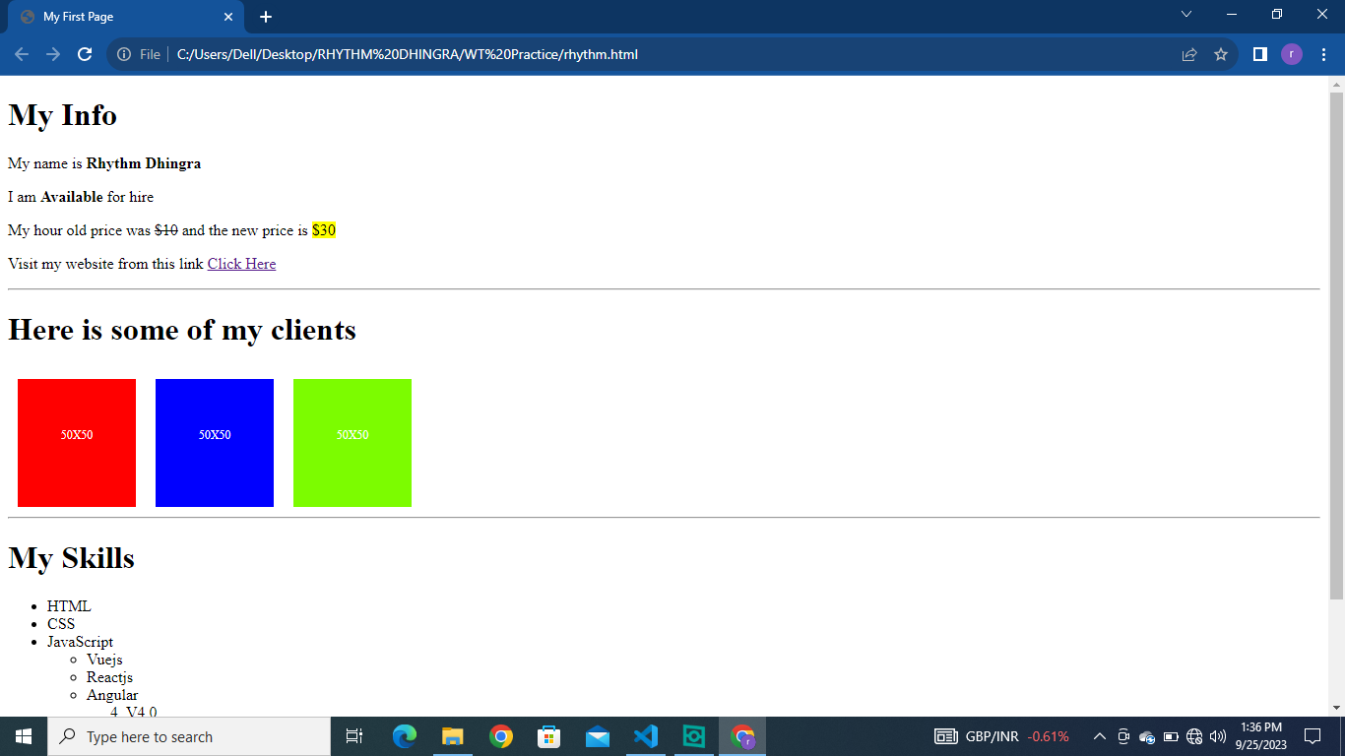

Practice Question-3

<!DOCTYPE html>

<html lang="en">

<head>

    <meta charset="UTF-8">

    <meta name="viewport" content="width=device-width, initial-scale=1.0">

    <title>My 3rd Page</title>

</head>

<body>

    <h1> My Favorite Recipes</h1>

    <ul>

        <li>Recipe 1</li>

    </ul>

    <h1> Recipe 1</h1>

    <p>This is going to be my favorite recipe.</p>

    <h1>List of Ingredients:</h1>

    <ul>

        <li>Ingredient 1</li>

        <li>Ingredient 2</li>

        <li>Ingredient 3</li>

    </ul>

    <h1> Steps:</h1>

    <ol>

        <li>Step 1</li>

        <li> Step 2</li>

        <li> Step 3</li>

    </ol>

</body>

</html>

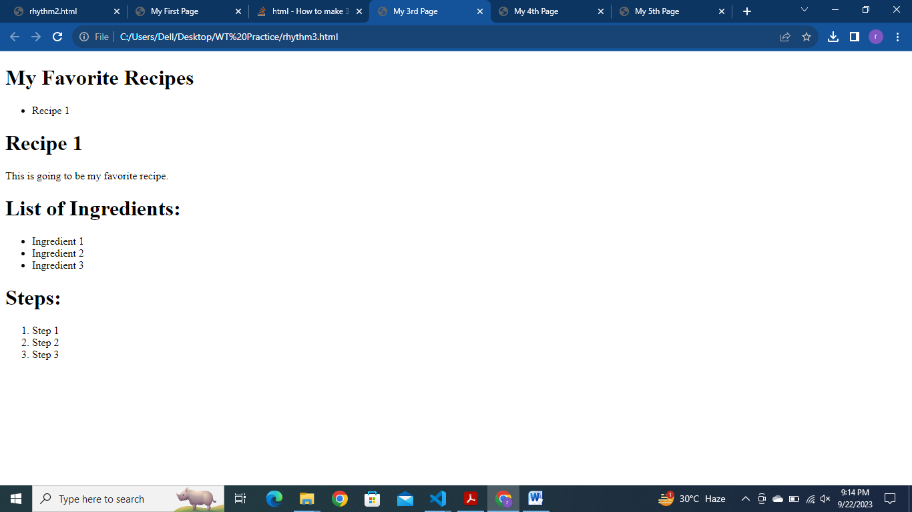

Practice 4:

<!DOCTYPE html>

<html lang="en">

<head>

    <meta charset="UTF-8">

    <meta name="viewport" content="width=device-width, initial-scale=1.0">

    <title>My 4th Page</title>

</head>

<body>

    quote#1:<quote>"To suffer terribly and to know yourself as the cause:that is hell"</quote>-Jordan Peterson

    <hr>

    Time with the one You Love

    <hr>

    <p> You and me alone <br>

    Madness of world locked away<br>

 Peace and quiet  reginss</p>

 <hr>

 <p>Top Three Coding Languages

 </p>

 <ol>

    <li>Python</li>

    <li>SQL</li>

    <li>HTML5</li>

 </ol>

 <hr>

</body>

</html>

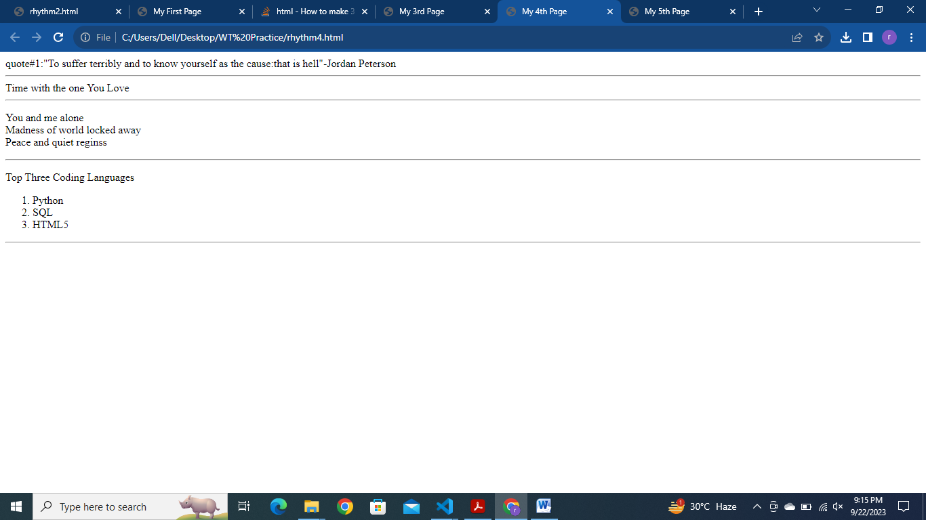

Practice Question 5:

<!DOCTYPE html>

<html lang="en">

<head>

    <meta charset="UTF-8">

    <meta name="viewport" content="width=device-width, initial-scale=1.0">

    <title>My 5th Page</title>

</head>

<body>

    <hr>

    <h1> My Favorite Recipes</h1>

    <ul>

        <li><a href="#soup">Soup</a></li>

        <li><a href="#salad">Salad</a></li>

        <li><a href="#pizza">Pizza</a></li>

    </ul>

    <h1 id="soup"> Soup</h1>

    <img src="soup.jpg" height="100px" width="100px">

    <p>Beetharvan once said "Only the pure of heart can make a good soup".Well,here's my attempt at doing just that</p>

<ol>

    <li> Step 1</li>

    <li> Step 2</li>

    <li> Step 3</li>

    <li> Enjoy!</li>

</ol>

<h1 id="salad"> Salad</h1>

<img src="salad.jpg"height="100px" width="100px">

<h1>List of ingredients</h1>

<ul>

    <li>Ingredient 1</li>

    <li>Ingredient 2</li>

    <li> Ingredient 3</li>

</ul>

<p> Who can resize a fresh salad! Here's one of my favorites</p>

<ol>

    <li>Step 1</li>

    <li>Step 2</li>

    <li>Step 3</li>

    <li> Enjoy!</li>

</ol>

<h1 id="pizza">Pizza</h1>

<img src="pizza.jpg" height="100px" width="100px">

<p>Pizza,the king of comfort foods. Try this simple,take seriodam, </p>

<ol>

    <li>Step 1</li>

    <li>Step 2</li>

    <li>Step 3</li>

    <li> Enjoy!</li>

</ol>

</body>

</html>

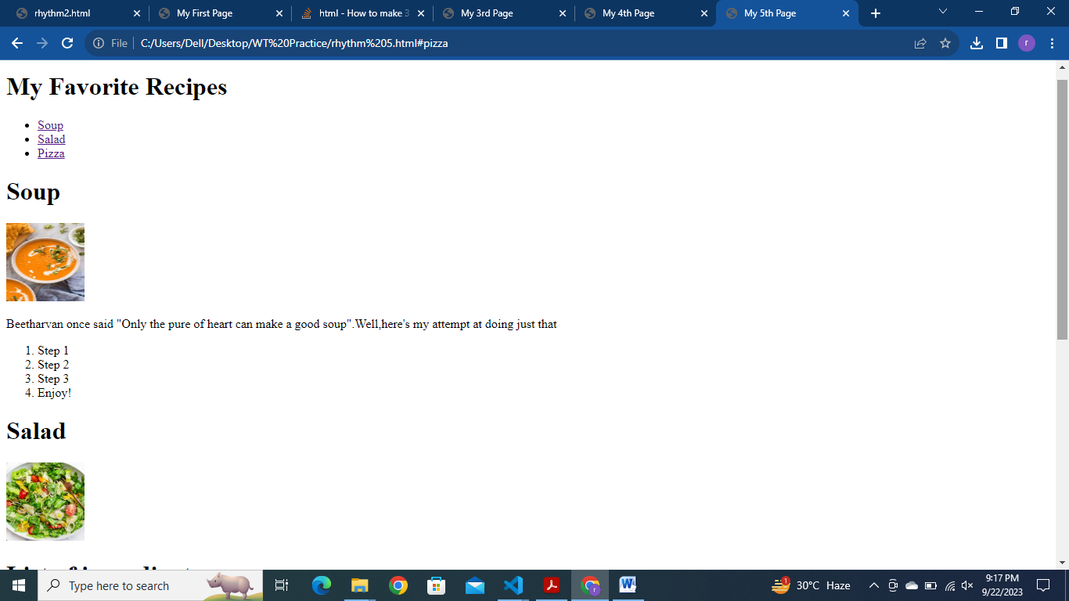

Practice Question 6:

<!DOCTYPE html>

<html lang="en">

<head>

    <meta charset="UTF-8">

    <meta name="viewport" content="width=device-width, initial-scale=1.0">

    <title>My Second Page</title>

</head>

<body>

    <h1> Andrew J Byrne</h1>

    <img src="download1.jpg" width="250" height="250">

    <p> Hello everyone! It is great to meet you all. I'm Andrew,one of the the <br>

    instructors for this course.<br>

Let me share a little bitabout myself.</p>

<h1> My hobbies are:</h1>

<ol>

    <li>Spending time withfamily and friends</li>

    <li>Swimming</li>

    <li>Learining</li>

</ol>

<p> Come say hello on Twitter at <a href="https://twitter.com/andrewjbyrne?lang=en">@AndrewJByrne</a></p>

</body>

</html>

